Event 1 : Event Status Updates (No email Notification)

Spark Message :

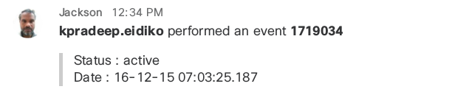

payload from Xmatters

{

"status": "active",

"username": "kpradeep.eidiko",

"eventIdentifier": 1719034,

"date": "16-12-15 07:03:25.187",

"eventProperties": []

}

============================================================================

Event 2 : Device Delivery Status (We will receive email notification)

Email Notification :

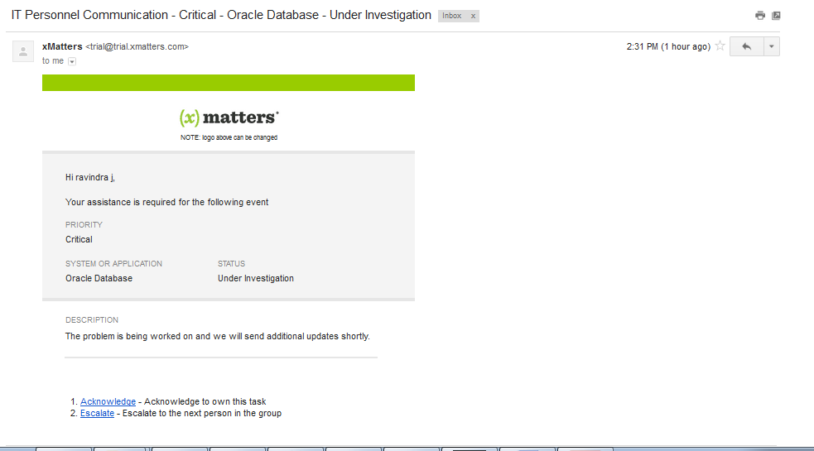

Spark Message:

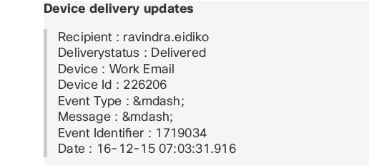

Payload from Xmatters

{

"recipient": "ravindra.eidiko",

"device": "Work Email",

"deliveryStatus": "Delivered",

"deviceId": 226206,

"eventType": null,

"message": null,

"eventIdentifier": 1719034,

"date": "16-12-15 07:03:31.916",

"eventProperties": [

]

}

============================================================

Event 3 : Notification Response (No email notification)

Spark Message :

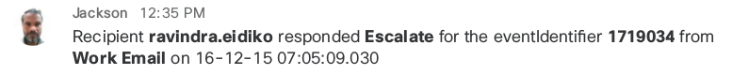

Payload from Xmatters :

{

"recipient": "ravindra.eidiko",

"device": "Work Email",

"response": "Escalate",

"annotation": "null",

"eventIdentifier": 1719034,

"date": "16-12-15 07:05:09.030",

"eventProperties": [

]

}

====================================================

Slack Notifications

-------------------------

To request the on-call members of the DBA team to the current channel in slack, enter the following command

/xmatters DBA

Slack Message :



Event Details in Xmatters :

